**Schema design for Employee Management Project:-**

1. create database employee_mangement;
2. use employee_mangement;
3. CREATE TABLE employee (

emp_id INT PRIMARY KEY AUTO_INCREMENT,

first_name VARCHAR(50) NOT NULL,

last_name VARCHAR(50) NOT NULL,

email VARCHAR(100) UNIQUE NOT NULL CHECK (email LIKE '%_@_%._%'),

contact BIGINT NOT NULL UNIQUE,

job_Title Varchar(20) NOT NULL,

department_id INT NOT NULL,

salary DOUBLE NOT NULL CHECK (salary >= 0)

) auto_increment =1001;

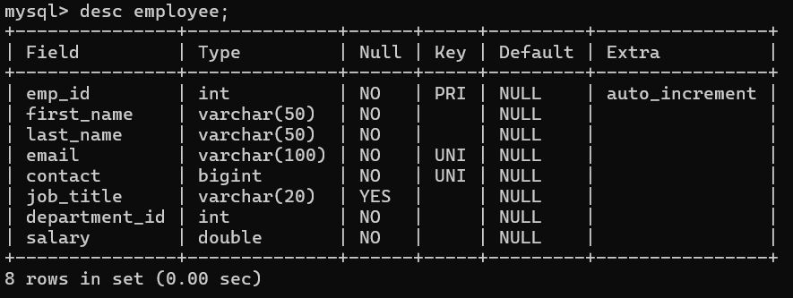

1. CREATE TABLE department (

department_id INT PRIMARY KEY AUTO_INCREMENT,

department_name VARCHAR(50) NOT NULL UNIQUE,

manager_id INT,

FOREIGN KEY (manager_id) REFERENCES employee(emp_id)

) auto_increment =2001;

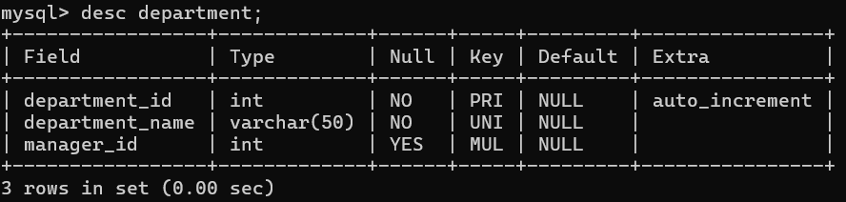

1. CREATE TABLE salary (

salary_id INT PRIMARY KEY AUTO_INCREMENT,

emp_id INT NOT NULL,

payment_date DATE NOT NULL,

amount DOUBLE NOT NULL CHECK (amount >= 0),

payment_method VARCHAR(20) CHECK (payment_method IN ('Bank Transfer', 'Cash', 'Cheque')),

FOREIGN KEY (emp_id) REFERENCES employee(emp_id)

) auto_increment =3001;

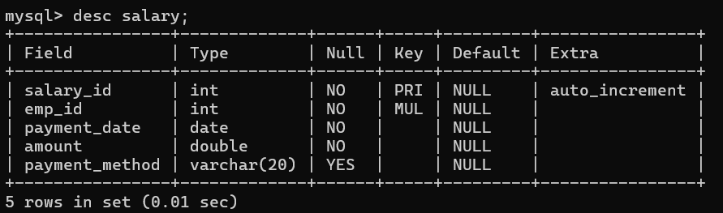

1. CREATE TABLE attendance (

attendance_id INT PRIMARY KEY AUTO_INCREMENT,

emp_id INT NOT NULL,

attendance_date DATE NOT NULL,

status VARCHAR(10) NOT NULL CHECK (status IN ('Present', 'Absent', 'Leave')),

FOREIGN KEY (emp_id) REFERENCES employee(emp_id)

) auto_increment =4001;

